CS 255 System Design Document

This template lays out all the different sections that you need to complete for Project Two. Each section has guidance to prompt your thinking. You will need to continually reference the interview transcript as you work to make sure that you are addressing your client’s needs. There is no required length for the final document. Instead the goal is to complete each section based on what your client’s needs are. Remove this note when you are finished, and replace all bracketed text with the relevant information.

UML Diagrams

UML Use Case Diagram

UML Activity Diagrams

Book Appointment
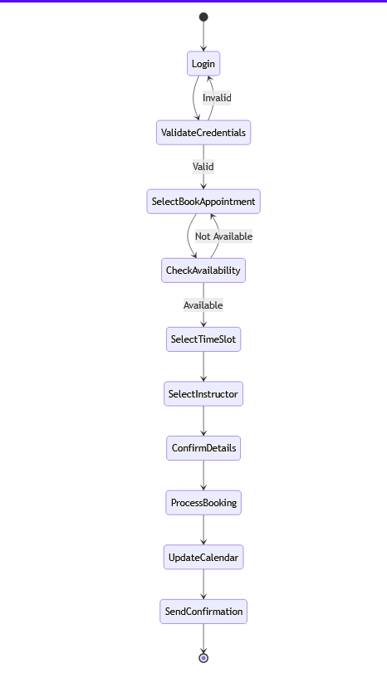

Take Online Test
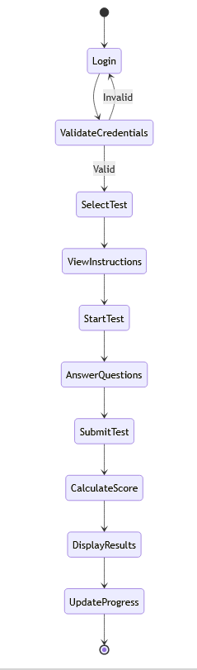

UML Sequence Diagram
Take Online Test
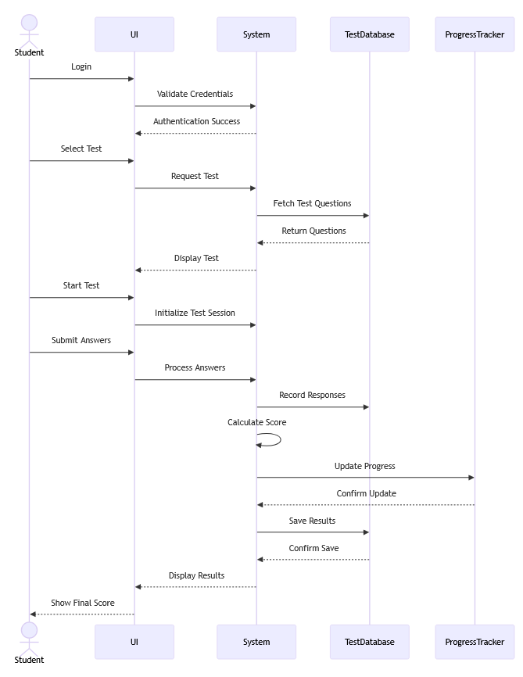

UML Class Diagram
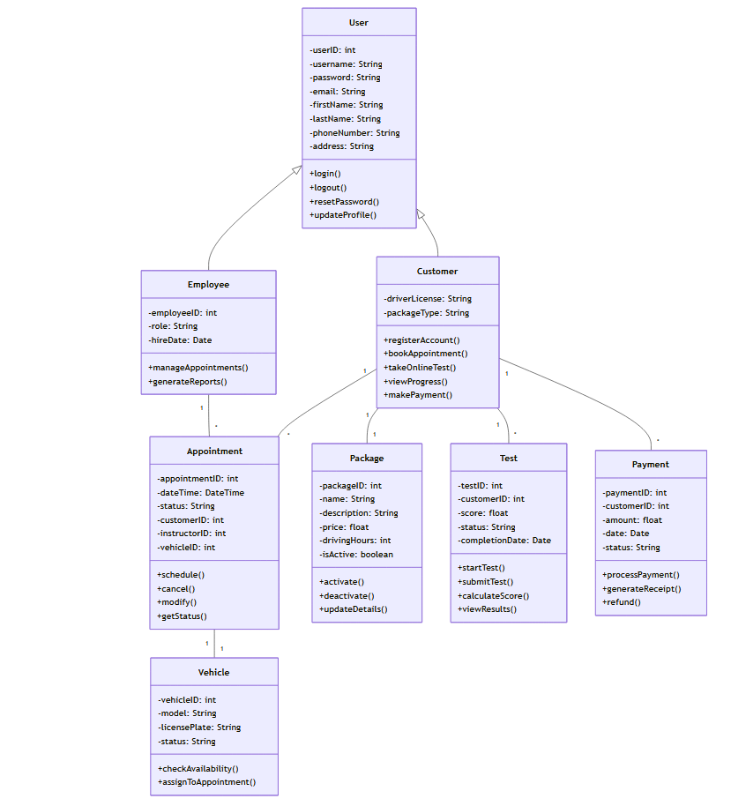

Technical Requirements
Hardware Requirements:
- Server Infrastructure
- Cloud-based servers with redundancy
- Load balancers for handling 100+ concurrent users
- Minimum 99.9% uptime guarantee
- Backup servers for disaster recovery
- Content Delivery Network (CDN) for optimal performance
- Client-Side Requirements
- Devices supporting modern web browsers
- Minimum screen resolution of 1024x768
- Internet connection (minimum 1Mbps)
- Sufficient processing power for web applications
Software Requirements:
- Backend Technologies
- Web server software (e.g., Nginx or Apache)
- Relational Database Management System (MySQL/PostgreSQL)
- Server-side programming language (e.g., Java/Python/.NET)
- API framework for third-party integrations
- SSL/TLS certificates for encryption
- Frontend Technologies
- HTML5, CSS3, JavaScript
- Responsive web framework (e.g., Bootstrap)
- Cross-browser compatible code
- Progressive Web App capabilities
- Modern JavaScript framework (e.g., React/Angular)
Infrastructure Requirements:
- Security
- Web Application Firewall (WAF)
- DDoS protection
- PCI DSS compliant payment processing
- Regular security scanning tools
- Automated backup systems
- Integration Components
- Payment gateway integration
- Email notification system
- SMS notification capability
- Document management system
- Reporting engine
Development Tools:
- Version Control
- Git repository
- CI/CD pipeline
- Code review tools
- Testing frameworks
- Monitoring Tools
- Application performance monitoring
- User activity tracking
- Error logging and reporting
- System health monitoring
- Analytics tools

